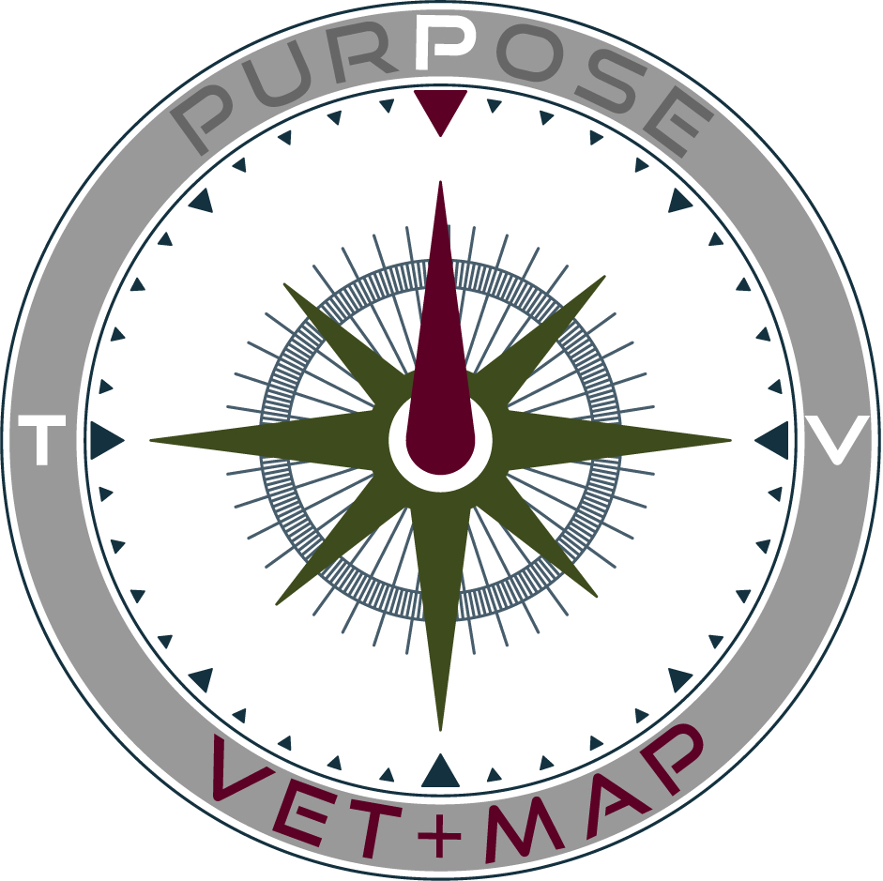
VET+MAP | p2i Funding Request Letter
To: [insert name]
Subject: Sponsoring my seat in a VET+MAP p2i Cohort
Dear [name],
I am writing to ask for your support as I pursue a transformational next step in my journey from military service into a purpose-aligned civilian life. I have been accepted into a VET+MAP p2i (Purpose to Impact) Cohort, and I am raising the participant portion of my seat cost so I can take part.
VET+MAP is a faith-informed, non-profit organization that comes alongside student-veterans to help them move out of the ‘Fog of Purpose’ and into clarity, direction, and impact. VET+MAP holds the conviction that every person was created by God, on purpose and for a purpose. The p2i Expedition is the structured, six-step process VET+MAP uses to help student-veterans discern that purpose and translate it into a clear post-service path.
Here is what participating in a p2i Cohort will provide, and why your investment matters:
Purpose Discernment Through the p2i Expedition: Facilitated sessions across the full six-step p2i process, guiding me from self-awareness to a concrete plan for post-service impact.
Assessment and Insight: Professional assessment instruments for talents, values, and purpose discernment, so my next chapter is built on evidence, not guesswork.
Coaching and Cohort Mentoring: One-to-one personal Sherpa plus small-group cohort mentoring with fellow student-veterans walking the same road.
Personal Brand and NorthStar Portfolio: Personal brand development materials and a final NorthStar portfolio I can carry into interviews, graduate school applications, and vocational conversations.
Alumni Network: Ongoing access to the VET+MAP alumni network and continued cohort community long after the program ends.
The total cost of a p2i seat is $3,000. As the participant, I am responsible for raising $2,000, and that amount is matched by a $1,000 corporate donation that completes my seat. That means your gift is leveraged: every dollar you contribute toward my $2,000 helps unlock the additional $1,000 match.
How your support will be applied:
Participant commitment (my responsibility): $2,000
Corporate matching donation (unlocked by my commitment): $1,000
Total seat value: $3,000
How the fundraising works:
- Register and acknowledge. During registration I confirmed my intent to raise $2,000 of the $3,000 cost for my seat.
- Raise it my way. Personal giving, sponsorships, and campus or employer support all count toward my total.
- Track progress. Every contribution posts to my dashboard with a receipt number and running balance.
- Meet the deadline. My commitment must be complete by my cohort’s registration deadline to hold my seat.
Any amount you are able to contribute, whether toward the full $2,000 or a portion of it, moves me closer to the starting line of this cohort and closer to the clarity and direction the p2i Expedition is designed to produce. Contributions are sent to me as designated seat-support funds, then remitted to VET+MAP through my participant portal, where each payment is receipted and posted to my $2,000 balance. I am glad to share my portal receipts or running balance with any donor who would like to see their gift applied.
Thank you for considering this request, and for standing with me as I work to move from the fog of transition into a clear, purpose-aligned path forward.
Respectfully,
[Your Name]
[Your University / Chapter, if applicable]
[Your Email]
[Your Phone Number]
About VET+MAP: VET+MAP is a non-profit organization serving student-veterans through the p2i (Purpose to Impact) Expedition, a six-step discernment and development process that helps veterans identify their God-given purpose and translate it into meaningful post-service impact. Learn more at vetmap.us.

